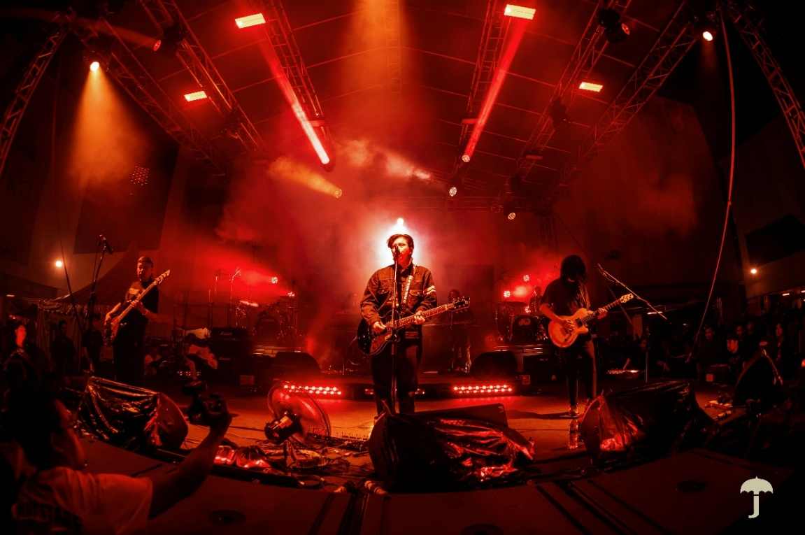

Hujan builds new touring standard with Sennheiser Spectera

Kuching, Malaysia, March 2026 – Formed in 2005, Malaysian alternative rock band Hujan has grown into one of the country’s most influential contemporary acts. Known for melodic songwriting, heartfelt lyricism, and dynamic live performances, the band has cultivated a loyal following across Malaysia and the region. Fronted by Noh Salleh, Hujan continues to evolve creatively while preserving the raw energy that first resonated with audiences two decades ago. Their chemistry on stage and close connection with fans remain central to their identity, making sonic precision and system reliability essential to every show.

At the recent Atas Angin Festival 2026 in February, Hujan deployed their Sennheiser Spectera wideband wireless ecosystem, reinforcing the system’s significance as the foundation of their live production workflow. Following its introduction in 2025, Spectera has now become central to the band’s touring infrastructure, unifying musicians, engineers, and crew within a single wideband RF environment.

From transition to standardisation
The band first introduced Spectera at Rock In The Jungle 2.0 at Sarawak Cultural Village in August 2025, where approximately 4,000 fans gathered. That performance marked Hujan’s move from rental-based in-ear monitoring to a fully integrated wideband ecosystem, designed to deliver greater depth, clarity, and operational control.

For years, the band had relied on renting Sennheiser’s IEM G4. When band manager Ariffin “Epain” Ahmad began exploring a long-term solution, the Sennheiser team arranged a demonstration session. The experience reshaped the band’s expectations of wireless monitoring.

Following the evaluation, Hujan invested in a complete Spectera setup: a Base Station, two DAD antennas, and 12 SEK bodypacks. These were deployed strategically across the team: four for the band members, two for sessionists, one each for monitor engineer Zunnun Zolaznan and RF engineer Amir Shah, and four for band crew. By integrating musicians, engineers, and crew into a single wideband network, the production operated cohesively rather than with separate monitoring and communication systems.

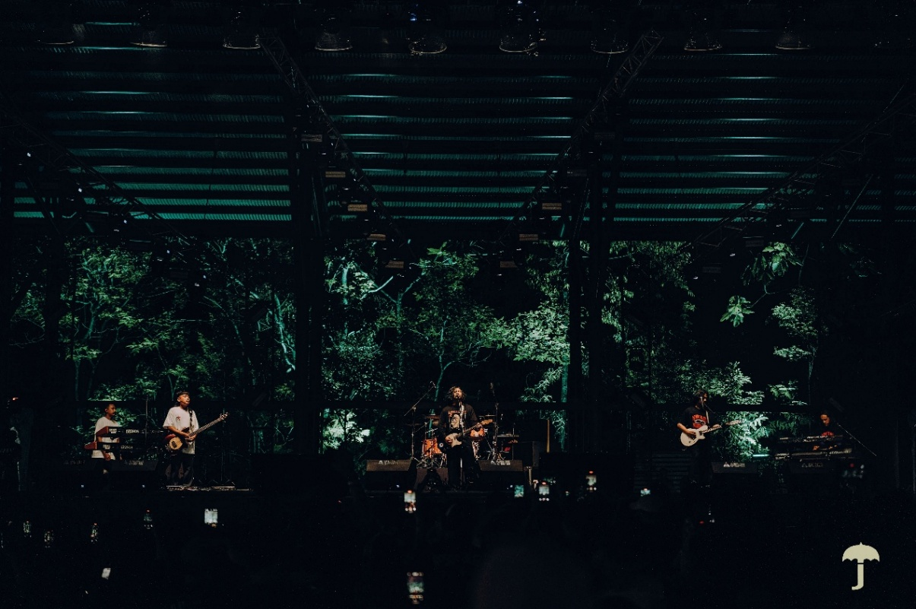Hujan relied on Spectera at Rock In The Jungle 2.0 Music Festival in Kuching

“From the very first demo, we knew Spectera was operating on a different level,” says Epain. “The setup was intuitive, the audio refined, and the system felt future-ready. Our decision was strengthened by the trust we have in Sennheiser and Acoustic & Lighting System, particularly their technical support.”

Guitarist AG Coco adds, “The clarity was striking. Every element in the mix felt defined yet natural. RF performance was rock solid, letting us focus purely on the music.”

Streamlined RF Across Major Festivals
At Rock In The Jungle 2.0, the deployment transmitted audio and control signals via a single wideband RF channel. Consolidating every link into one coordinated spectrum block eliminated the need to manage multiple narrowband frequencies, simplifying RF coordination.

“Managing one wideband channel reduces complexity and frees us to focus on optimisation rather than troubleshooting,” explains RF engineer Amir Shah. “Even with all users active across stage and backstage, oversight remained straightforward.”

In addition to Hujan’s own setup, Acoustic & Lighting System supplied an additional antenna and spare SEKs for redundancy. The streamlined configuration reduced hardware requirements and improved portability without compromising coverage.

Hujan deployed one Base Station, two DAD antennas, and 12 SEK bodypacks at their shows | 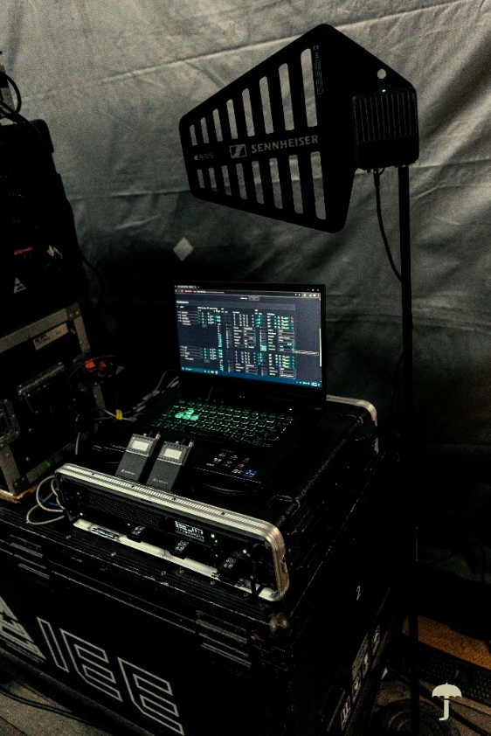

Spectera provided real-time system visibility across all users. Battery status, temperature, RF performance, and audio integrity were continuously monitored via the Spectera WebUI interface. “That level of transparency gives us complete control,” Amir adds. “Whether a musician on stage or a crew member offstage, we can see exactly what is happening at any moment.”

At Atas Angin Festival 2026, the same wideband configuration was deployed successfully, reinforcing Spectera’s consistency and reliability across different festival environments.

Greater Clarity, More Musical Monitor Mixes
Monitor engineer Zunnun Zolaznan noticed the difference from the first soundcheck in 2025. “The sound was open, clear, and highly detailed. Since the signal path is so clean, I don’t need heavy processing to create separation. The result is a more organic and transparent mix,” he says.

He also highlights how ambience is perceived through the Spectera IEMs. “The ambience sounds natural and spacious. It’s not just a loud, generic sound; it’s detailed and clear,” Zunnun explains. “That sense of depth enhances the band’s connection to the crowd.”

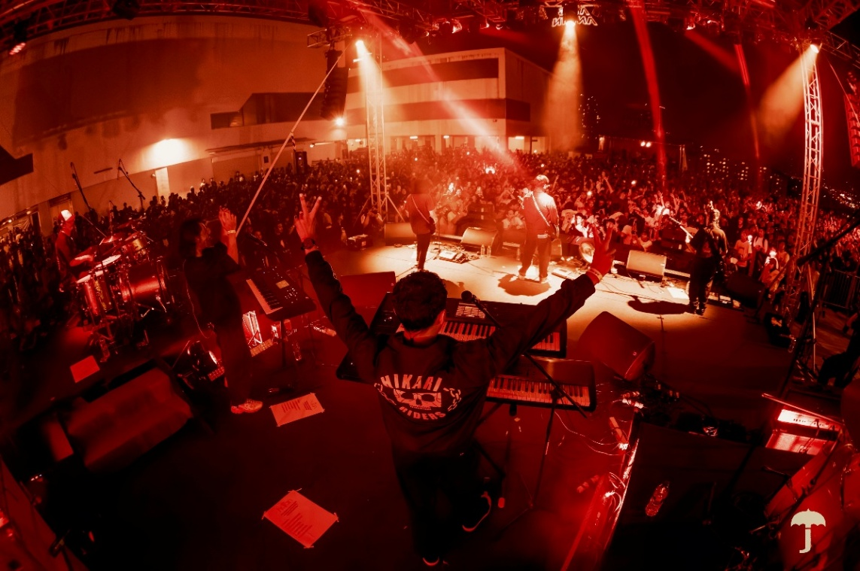
Hujan delivered an electrifying performance at the Atas Angin Festival 2026

The reliability of the system reshaped workflow. “Managing a single RF channel for all users makes oversight much easier. Throughout the show, performance was flawless,” Zunnun adds.

“This confidence transforms the entire production,” Epain notes. “Artists and technicians can hear every nuance clearly. The assurance that the system will remain stable removes a significant layer of stress. Sennheiser’s support was professional and comprehensive, making the transition seamless.”

Elevating the entire production ecosystem
FOH engineer Ahmad Syafiq highlights Spectera’s impact on overall production. “What stood out immediately was how quickly the system could be deployed and how expansive the soundstage felt. In terms of audio integrity, RF stability, and deployment speed, it surpassed everything else we evaluated,” he says.

Although in-ear monitoring does not directly alter the FOH mix, its impact is felt throughout the production. “When the band performs with confidence and precision, it elevates the entire show. The performance feels tighter and more refined for the audience. The WebUI provides an impressive depth of information for RF management, streamlining workflow across all connected SEKs,” he adds.

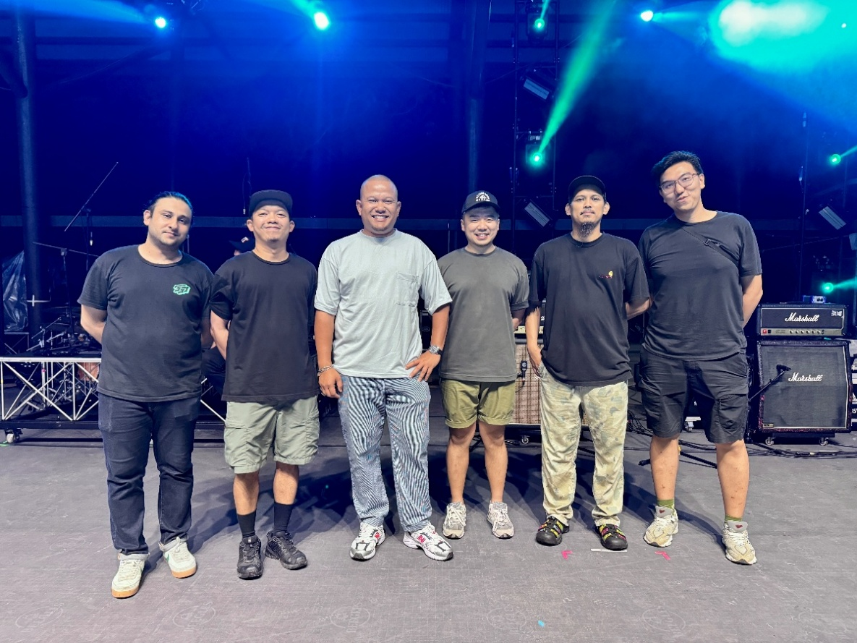
(L-R) Amir Shah, RF Engineer, Ahmad Syafiq, FOH Engineer, Epain Ahmad, Band Manager, Tyler Tan, Sennheiser Artist Relations Manager, Zunnun Zolaznan, Monitor Enginner and Rain Ong, Product Specialist at Acoustic & Lighting System at Rock In The Jungle 2.0

Looking ahead, the band is confident in their setup. “We intend to continue building our shows around Spectera. The Sennheiser team and Acoustic & Lighting System have been invaluable partners for a product that represents a major technological advancement,” Syafiq adds.

A Touring Backbone for the Future
What began as a strategic investment in 2025 has now become foundational to Hujan’s live production. From its debut at Rock In The Jungle 2.0 to Atas Angin Festival 2026, Spectera has established itself as a consistent and reliable system, enhancing on-stage clarity, simplifying RF management, and reinforcing operational confidence across every major performance. Having experienced the control, cohesion, and sonic depth it delivers, returning to their previous setup is no longer under consideration.

(Ends)

The high-resolution images accompanying this media release can be downloaded here.

About the Sennheiser brand
We live and breathe audio. We are driven by the passion to create audio solutions that make a difference. Building the future of audio and bringing remarkable sound experiences to our customers – this is what the Sennheiser brand has represented for 80 years. While professional audio solutions such as microphones, meeting solutions, streaming technologies and monitoring systems are part of the business of Sennheiser electronic SE & Co. KG, the business with consumer devices such as headphones, soundbars and speech-enhanced hearables is operated by Sonova Holding AG under the license of Sennheiser.

www.sennheiser.com
www.sennheiser-hearing.com

Press Contact
Su Hui Phang
suhui.phang@sennheiser.com
M +6569325930

